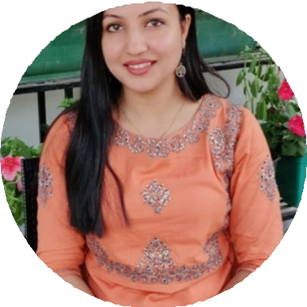

Panjabari, Guwahati, Assam

+918134934525

[mehsinasabnam10@gmail.com](mailto:mehsinasabnam10@gmail.com)

**EDUCATION**

* Ph.D. in Linguistics, Tezpur University (10th April 2023)
* M.A. in Linguistics, Gauhati

University (2017)

* M.A. in English Literature,

IGNOU (2020)

* B.A. in English, Cotton College

(2015)

* HSSLC, BVA North Lakhimpur

(2012)

* HSLC, St. Mary's High School,

North Lakhimpur (2010)

DR. MEHSINA SABNAM

**ASSISTANT PROFESSOR**

I am an Assistant Professor in the Department of English at the University of Science and Technology, Meghalaya. I hold a Ph.D. and M.A. in Linguistics from Gauhati University, as well as an M.A. in English Literature from IGNOU. With my expertise, I have also qualified for the UGC- NET. My academic interests include linguistics, English literature, and innovative pedagogical practices, through which I strive to inspire and educate my students.

**EXPERIENCE**

**Assistant Professor**

Department of English, USTM | August, 2023 - present

One year teaching experience in Communicative English at Tezpur University. 2018-2019

TRAINING & WORKSHOPS UNDERTAKEN

* Workshop on Teaching Language Skills in the department of English and

Foreign Languages, Tezpur University.

* Workshop on Lexicography at the department of English and Foreign Languages, Tezpur University.
* Training program on Language Documentation and Linguistic Tools at Northeastern Regional at CIIL, Guwahati.

SEMINARS, CONFERENCES AND PUBLICATIONS

* Presented a paper at the 40th International Conference of the Linguistic Society of India, CIIL, Mysore (05-07 December 2018).
* Presented a paper at a National Seminar, Dibrugarh University (30 March 2019).
* Presented a paper at a National Seminar, Tezpur University on Indigenous and Lesser Studied Languages (29-31 October 2019).
* Presented a paper at the 40th Linguistic Society of Nepal, Tribhuvan University, Nepal (26-27 November 2019).
* Presented a paper at the 11th International Conference of North East Indian Linguistic Society, Kokrajhar (7-9 February 2020).
* Research paper titled “A Comparative Study of Color Expressives in Bodo, Deori and Mising” in Sodh Sanchar Bulletin (UGC CARE LIST), Volume 11, Issue 41, January-March 2021. Authors: Mehsina Sabnam and Arup K. Nath. Editor: Dr. Vinay Kumar Sharma.
* Research paper titled "Semantic Features Associated with Expressives in Mising" in Rabindra Bharati Patrika (UGC CARE LISTED), January 2024. ISBN: 09750037.
* Research paper titled "Identifying the Word Classes of Expressives in Bodo, Deori, and Mising" in Aligarh Journal of Linguistics (UGC CARE LIST), Volume 11, 2021-2022. Authors: Mehsina Sabnam and Arup K. Nath. Editors: Nazrin B. Laskar and Masood Ali Beg. ISSN: 2249-1511.
* Book chapter titled “Expressives in Bodo” in “Queries in the Structure of Language” by CIIL & LSI.
* Book chapter titled “Language Contact and Shifting Among Deori Speakers” in “CREDENCE II” (ISBN).