CURRICULUM VITAE

Personal Information:

NAME : Prof. Thagi Ram Gogoi
Designation : Prof, DEAN, SSSH/Chairman (SRC)
School of Social Science and Humanities, University of Science and Technology Meghalaya
QUALIFICATION : MA, M PHIL, PHD
DATE OF BIRTH : 28-01-1956
CORRESPONDENCE ADDRESS : Lakhimi Nagar, House no 12, Ratigan, Guwahati,
MOBILE NO : +917896028735
E-Mail : thagiramustm@gmail.com
SEX : MALE

Educational Qualifications:

Qualification | Year | Board/University
Ph. D | 2002 | Dibrugarh University
M. Phil | 1989 | Dibrugarh University
Post Graduation (Sociology) | 1987 | Dibrugarh University
Graduation | 1984 | Dhakuakhana College under Dibrugarh University
HS | 1981 | A.H.S.E.C
HSLC | 1979 | S.E.B.A

- Completed a six months diploma course in Diploma in Computer Application (DCA) in 2013.

Dissertation / Thesis:
- Ph.D- Role of Adult Education Programme and its Impact on Rural committee in Assam in the year 2002 in Dibrugarh University.
- M. Phil- Integrated Child Development Scheme: A Study on Lakhimpur District in the year 1989 under Dibrugarh University.
Papers Published -
43 Research Paper Publications in both UGC CARE List and SCOPUS journals.
Book Chapters:
- 7 book chapters published in various research-based peer reviewed books.
And authored 4 books in the domain of Sociology.

Seminar Presentations:
Presented papers in 15 National and International Seminars.

Workshops Attended:
7 workshops attended.

Work Experience:

- June 1988 started as an Assistant Professor in Kamaboria College, Majuli, Assam.
- June 2001 started as an Assistant Professor in Gogamukh College, Lakhimpur
- December 2013 worked as Principal, Gogamukh College, Lakhimpur.
- June 2017 worked as Professor in University of Science and Technology, Meghalaya.

Awards and Achievements:
UGC Grant Projects: 1

Hobbies and Interests:
- Reading
- Swimming
- Sports

Languages known:
- Assamese
- English
- Hindi

Declaration: I solemnly declare that all the above information and facts are true to the best of my knowledge and belief.

Place: Guwahati
Date: 18/2/2025
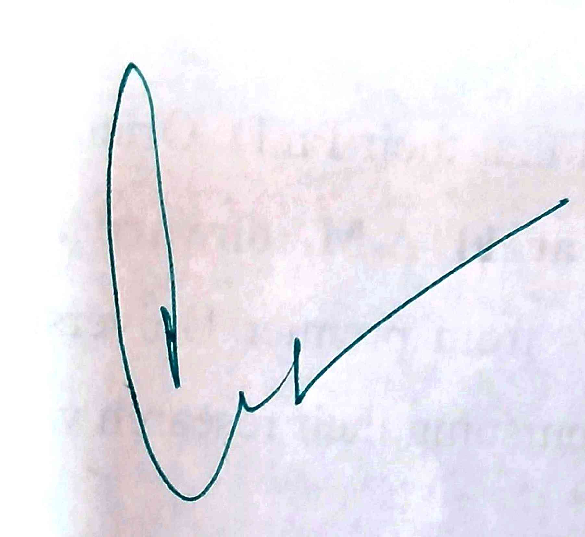

(Professor Thagi Ram Gogoi)

